Weekly Coursework Value Stream Summary
Glossary:
- VA: Value-Added Time (time spent on activities that directly contribute to learning outcomes)
- NVA: Non-Value-Added Time (time spent on activities that do not directly contribute to learning outcomes, such as waiting or administrative tasks)

1. Major Workflow Stages and Average Time Spent
Assignment Work
- Average Time: 3.0 hours
- VA/NVA Mix: Mostly VA, some NVA
Discussion Post
- Average Time: 1.5 hours
- VA/NVA Mix: Mostly VA, posting is NVA
Peer Replies
- Average Time: 3.25 hours
- VA/NVA Mix: Mix of VA and NVA

2. Total Weekly Time
Total Time Spent: 7.75 hours
Value-Added Time (VA): 390 minutes
Non-Value-Added Time (NVA): 75 minutes
Flow Efficiency: 84%
Formula: Flow Efficiency = VA / (VA + NVA)

3. Flow Chart
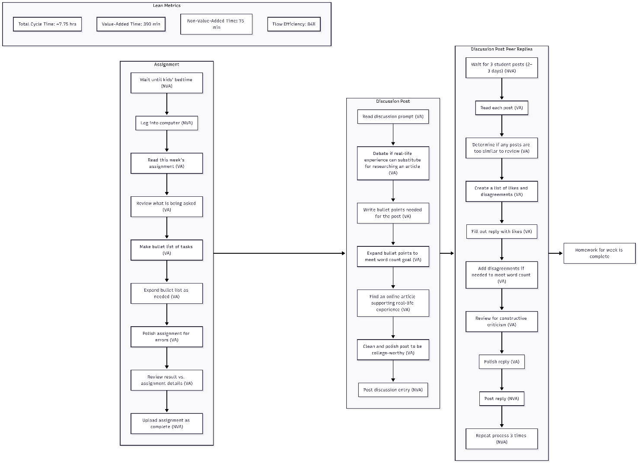

4. Optimization Opportunities
Reduce Non-Value-Added Time
Waiting for Peer Posts
- Check replies only at scheduled times (At least 2 days after posting, but before the deadline) or wait till later in week to do first post, then check for replies in one block of time
- Pre-draft reply templates to reduce turnaround time
Startup Overhead
- Create a “Course Start Checklist”
- Review all weekly assignments in one planning block
Improve Assignment and Discussion Writing Efficiency
Standardized Templates
- Assignment template
- Discussion post template
- Peer reply template
Batch Similar Tasks
- Read all materials together
- Write all content together
- Polish all content together
Automate or Systematize Repetitive Work
- Use Grammarly or Word Editor for polishing
- Use Google Calendar reminders for discussion deadlines
- Use Copilot to review accuracy of assignment and discussion content before posting
Future-State Goal
Reduce weekly NVA time from 75 minutes to 30 minutes, increasing flow efficiency from 84% to 92%.

References:
Used to help create the value stream map in mermaid syntax: Microsoft. (2026). Microsoft Copilot [Large language model]. Microsoft. https://www.microsoft.com/copilot

